|  |  |
| --- | --- |
| **Experiment No. 7 c) Date :** | **CHARACTERISTICS OF BJT (CE CONFIGURATION)** |
| **Name of candidate:**    **Register Number:**    **Date of Experiment:**    **Date of submission:** | **Debarghya Barik**  **RA2011026010022**  **10.12.2020**  **14.12.2020** |

**Aim**

To plot the transistor (BJT) characteristics of CE configuration.

# Apparatus Required Components Required

|  |  |  |  |  |  |  |  |  |
| --- | --- | --- | --- | --- | --- | --- | --- | --- |
| **S.No.** | **Name** | **Range** | **Qty** |  | **S.No.** | **Name** | **Range** | **Qty** |
| 1 | R.P.S | (0-30)V | 2 | 1 | Transistor | BC 107 | 1 |
| 2 | Ammeter | (0–30) mA  MC | 1 | 2 | Resistor | 10 K | 1 |
| (0–250) µA  MC | 1 | Resistor | 1 K | 1 |
| 3 | Voltmeter | (0–30)V  MC | 1 | 3 | Bread  Board |  | 1 |
| (0–1)V  MC | 1 | 4 | Wires |  |  |

# Theory

A BJT is a three terminal two – junction semiconductor device in which the conduction is due to both the charge carrier. Hence it is a bipolar device. BJT is classified into two types – NPN & PNP. A NPN transistor consists of two N types in between which a layer of P is sandwiched. The transistor consists of three terminal emitter, collector and base. The emitter layer is the source of the charge carriers and it is heavily doped with a moderate cross sectional area. The collector collects the charge carries and hence moderate doping and large cross sectional area. The base region acts a path for the movement of the charge carriers. In order to reduce the recombination of holes and electrons the base region is lightly doped and is of hollow cross sectional area. Normally the transistor operates with the EB (emitter-base) junction forward biased.

**Procedure**

# Input Characteristics

1. Connect the circuit as per the circuit diagram.
2. Set VCE, vary VBE in regular interval of steps and note down the corresponding IB reading. Repeat the above procedure for different values of VCE.
3. Plot the graph: VBE Vs IB for a constant VCE. **Output Characteristics**
4. Connect the circuit as per the circuit diagram.
5. Set IB, Vary VCE in regular interval of steps and note down the corresponding IC reading. Repeat the above procedure for different values of IB.
6. Plot the graph: VCE Vs IC for a constant IB.

# Pin Diagram

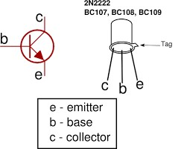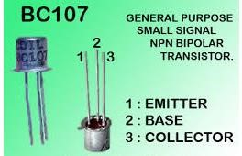

Specification: BC107/50V/0.1A,0.3W,300 MH

# Circuit Diagram

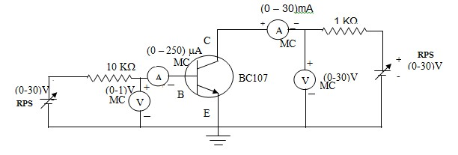

**E-Circuit Diagrams:**

1. **Input Characteristics:**

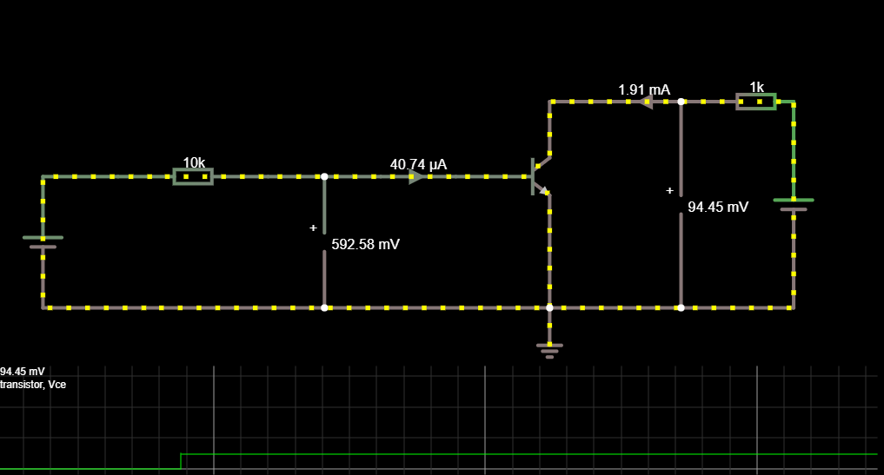

1. **Output Characteristics:**

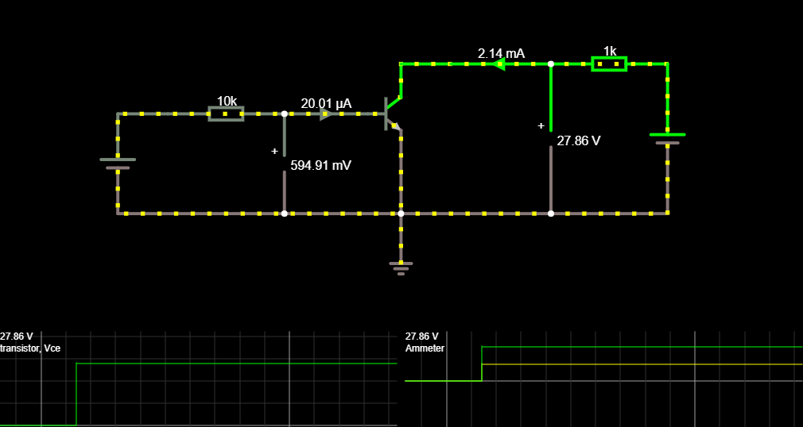

**Model Graph**

# Input Characteristics Output Characteristics



V

CE

=

0

V



V

CE

=

5

V



I

B



µA



mA



V

BE

(

)

V



V

CE

(

V

)



0



0



I

B

=60

❍

A



I

B

=40

❍

A



I

B

=

2

0

❍

A



I

C

# Tabular Column

# Input Characteristics

|  |  |  |  |  |  |
| --- | --- | --- | --- | --- | --- |
| **VCE = 0 V** | |  |  | **VCE = 2V** | |
| **VBE(V)** |  | **IB(μA)** | **VBE(V)** |  | **IB(μA)** |
| 0.517 |  | 48.31 | 0.593 |  | 40.74 |
| 0.558 |  | 244.25 | 0.598 |  | 240.23 |
| 0.572 |  | 442.76 | 0.602 |  | 439.84 |
| 0.591 |  | 940.88 | 0.609 |  | 940.08 |
| 0.601 |  | 1440 | 0.615 |  | 1440 |
| 0.609 |  | 1940 | 0.620 |  | 1940 |
| 0.615 |  | 2440 | 0.624 |  | 2440 |
| 0.620 |  | 2940 | 0.627 |  | 2940 |

# Output Characteristics

|  |  |  |  |
| --- | --- | --- | --- |
| **IB=20μA** | | **IB=40μA** | |
| **VCE(V)** | **IC(mA)** | **VCE(V)** | **IC(mA)** |
| 0.089 | 0.907 | 0.070 | 0.930 |
| 0.859 | 2.14 | 0.118 | 2.88 |
| 2.86 | 2.14 | 0.722 | 4.28 |
| 7.86 | 2.14 | 5.72 | 4.28 |
| 12.86 | 2.14 | 10.72 | 4.28 |
| 17.86 | 2.14 | 15.72 | 4.28 |
| 22.86 | 2.14 | 20.72 | 4.28 |

***Graph:***

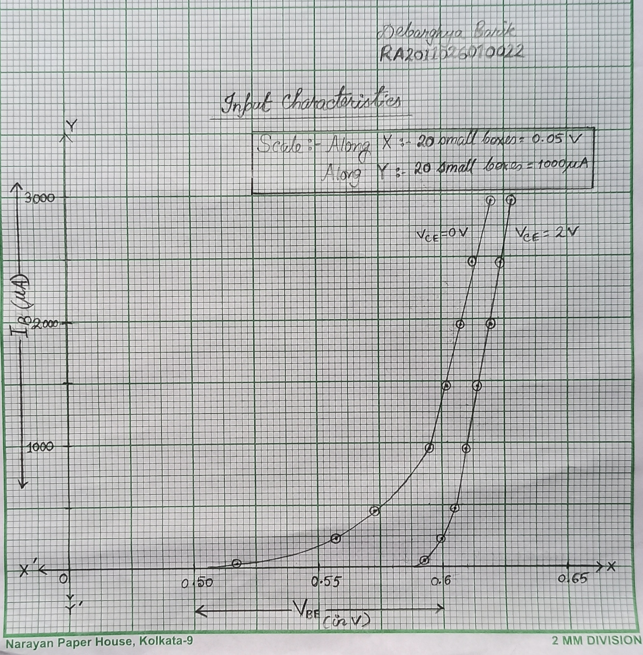

**Input Characteristics Graph**

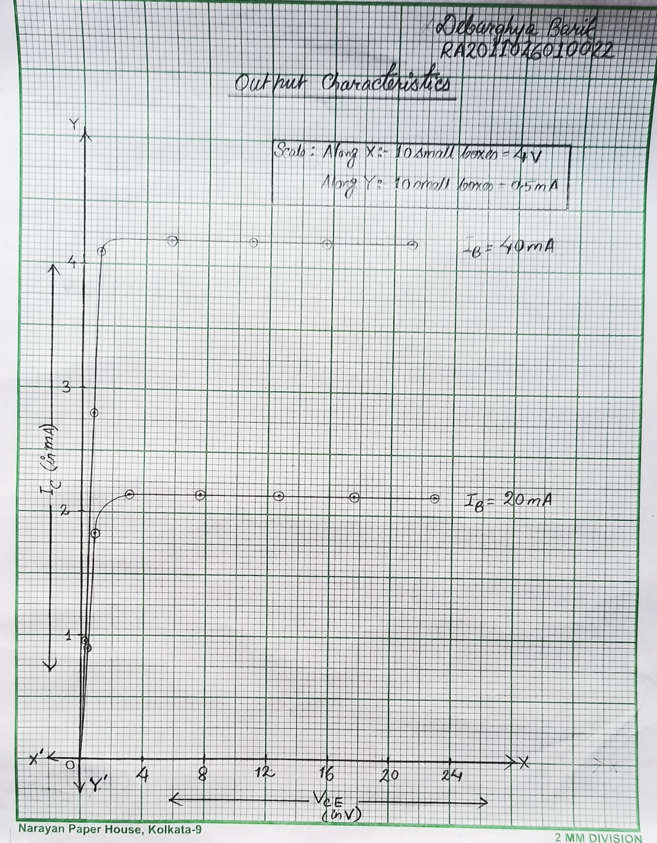

**Output Characteristics Graph**

**Result:**

The circuit was drawn, the readings were tabulated and the graphs were drawn and from the calculations Input characteristics and Output Characteristics of the BJT were studied

# POST LAB QUESTIONS

1. **What is Punch through voltage?**

**Ans:** The reverse-bias voltage applied to the drain terminal that results in significant drain-to-source current even though the transistor is biased in its off state. Also, it is defined as emitter-to-collector breakdown which can occur in a junction transistor with very narrow base region at sufficiently high collector voltage when the space-charge layer extends completely across the base region

1. **What is early effect?**

**Ans:** The Early effect, is the variation in the effective width of the base in a bipolar junction transistor (BJT) due to a variation in the applied base-to-collector voltage. It is caused when a greater reverse bias across the collector- base junction increases the collector-base depletion width.

1. **What are the differences between NPN and PNP transistors?**

**Ans:**

|  |  |
| --- | --- |
| **A NPN Transistor** | **A PNP Transistor** |
| In an **NPN transistor**, a positive voltage is given to the collector terminal to produce a current flow from the collector to the emitter. | In a **PNP transistor**, a positive voltage is given to the emitter terminal to produce current flow from the emitter to collector. |

1. **What is leakage current and mention its range?**

**Ans:**  Leakage current is the current due to the minority charge carriers, flowing in the transistor. It flows in the same direction as the current due to the majority charge carriers. When the supply at the emitter base junction is open circuited, there is only reverse biasing in the base collector junction. Therefore, this sets up a small amount of current called the leakage current.

**The range of leakage current** is typically very low, usually in either the low µA (micro-amps, or 10-6 amps) **range** or even the nA (nanoamps, or 10-9 amps) **range**.

1. **What is base – width modulation?**

**Ans:**  The base width modulation is the variation in the width of the base in a bipolar transistor due to a variation in the applied base-to-collector voltage. The effective base width is the function of the voltage Vce. So, when voltage Vce is increased, the effective base width reduces and because of that, the chances of recombination in the base region reduces.

---------------------------------------------------X-------------------------------------------------